**Curriculum Vitae**

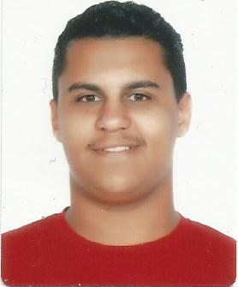

**Personal Details:**

* **Name**  : Ahmad Ebrahim AbdulNabi Hasan Ebrahim Sabt
* **Nationality** : Bahraini
* **Date of Birth** : 22-09-2000
* **Sex**  : male
* **Marital Status** : Single
* **CPR No**  : 000907588
* **Address** : House 708-Road 7720 Al-Shakhora 477 ( Kingdom o Bahrain)
* **Telephone** : 66601465
* **E-mail** : Ahmad.sabt900@gmail.com

**Education & Qualifications**:

2015-2018

Jidhafs Secondary Technical Electrical Section

**Languages:**

Arabic: Excellent – speaking & writing...

English: Good– speaking & writing...

**Projects & Assignments:**

* Technical skills: Well in use of Microsoft office (word, Access,) & searching through the internet.
* Personal skills: Effective communicational & analytical skills.
* Ability to work under pressure and to do team work.

**Hobbies:**

* Reading books & stories.
* Playing football
* Using internet